Project Proposal



Axion

A Modern Digital Banking Solution

**Submitted To :**

Name: Shadman Rabby

Lecturer , Department of CSE, Daffodil International University.

|  |  |
| --- | --- |
| **Submitted By :** | |
| Avisheikh Kundu | 221-15-5009 |
| Ovi Sarker | 221-15-4736 |
| Robiul Hasan Nafis | 221-15-5099 |
| B. M. Sabbir Hossen Riad | 221-15-5267 |
| Jannatul Firdaus Mariam | 221-15-5644 |
| Section : 61_“O1” | |
| Department of CSE | |
| Daffodil International University | |

|  |  |
| --- | --- |
| Submission Date | 31-10-2024 |

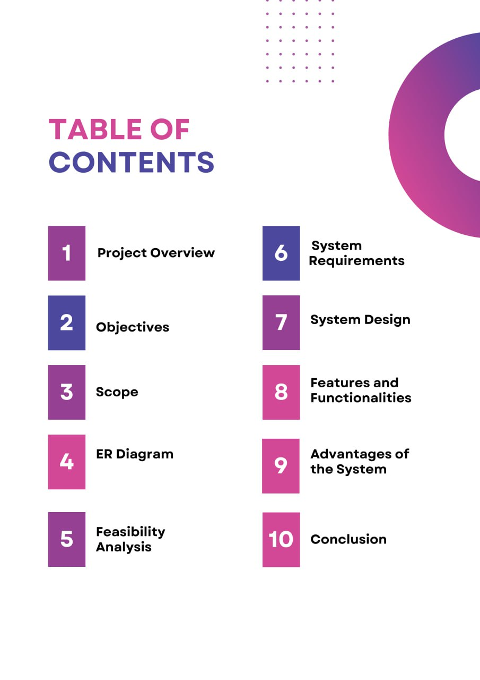

**Project Name:** **Axion360°**

### **Project Overview :** Axion Bank PLC has a modern digital banking solution which performs as an online banking platform. Axion360**°** is an online banking platform designed to provide customers with secure, fast, and accessible financial services. Leveraging a robust database system, this project aims to streamline essential banking operations and improve user experience by making services accessible online. Axion360**°** aspires to be a modern, customer-centered digital bank that provides a wide range of services from account management to transaction handling, all through an intuitive interface.

### **Project Objectives**

**Enhance Accessibility and Convenience**

* Provide customers with a 24/7 online platform to access their accounts and conduct banking transactions from any device (desktop, tablet, or smartphone).
* Eliminate the need for physical branch visits, allowing customers to manage their finances at their convenience.

**Ensure High Security and Data Integrity**

* Implement robust security protocols, including SSL encryption, secure password storage, and access controls, to protect sensitive customer information.
* Ensure data integrity and prevent unauthorized access to customer accounts and transaction details.

**Optimize Transaction Processing**

* Enable quick and reliable processing of various transactions, including deposits, withdrawals, and fund transfers, to enhance user satisfaction.
* Provide real-time updates to customers on transaction status and account balances to improve transparency.

**Simplify Account Management**

* Allow customers to manage different types of accounts (savings, current, and student accounts) seamlessly through a single platform.
* Display account balance, transaction history, and downloadable statements for each account, helping users track and manage their finances efficiently.

**Create a User-Friendly and Intuitive Interface**

* Design an interface that is easy to navigate for all users, regardless of their technical proficiency, to encourage regular platform usage.
* Provide a consistent and professional look and feel across different devices, ensuring an enjoyable user experience.

**Facilitate Efficient Database Management and Scalability**

* Design a well-structured, normalized database schema that allows for quick data retrieval and transaction processing.
* Build the database to be scalable, enabling it to handle an increasing number of customers, accounts, and transactions as Axion Bank PLC. grows.

**Implement Comprehensive Reporting and Search Features**

* Provide detailed reports on transactions and account activities, helping administrators and customers monitor financial activities accurately.
* Include search functionalities to allow customers and staff to quickly locate specific transactions or account details by various filters.

**Ensure Minimal Errors and Maximum Data Accuracy**

* Integrate validation and error-handling mechanisms to minimize the occurrence of transaction errors and ensure the accuracy of recorded data.
* Regularly back up the database and maintain audit logs to enable error recovery and data restoration when needed.

**Reduce Operational Costs and Improve Efficiency**

* Streamline banking processes, reducing the need for physical paperwork and in-person customer service, which results in operational cost savings.
* Automate repetitive tasks, enabling bank employees to focus on higher-level functions and customer support.

**Deliver High-Quality Customer Service**

* Provide customers with secure access to real-time financial information, account management options, and efficient transactions.
* Enhance customer satisfaction and loyalty by offering a reliable and seamless online banking experience that caters to their banking needs.

**Scope:**

The Axion360**°**. system will cover a broad range of banking functionalities, including:

* User Registration and Authentication: Secure sign-up, login, and multi-factor authentication for user verification.
* Account Management: Support for multiple account types (e.g., savings, current, student) and features such as balance inquiries and account history.
* Transaction Processing: Enable secure transactions like deposits, withdrawals, and inter-account transfers.
* Customer Information Management: Maintain customer data, ensuring accuracy and easy access for administrative and customer support purposes.
* Reporting and Auditing: Detailed transaction logs and account reports, enabling users and administrators to track and monitor financial activity.

**The project excludes:**

* Physical bank operations or in-person customer service.
* Advanced financial products like loans, credit cards, or investments at this stage.

**ER Diagram:**

2222222

**Schema:**

**User**( User_ID , Password, Name, NID, DOB, Address)

**Customer**(Customer_ID, User_info, Acc_Info, Add_Account, User_ID)

_ _ _ _ _ _

**Account**(Account_No, User_ID, Account _type, Balance, Statement)

_ _ _ _ _ _

_ _ _ _ _ _ _ _ _ _

**Transaction**(Transaction_ID, Acc_ID, Transaction_Date, Transaction_Type,

_ _ _ _ _ _

Deposit, Amount, Withdraw, Transfer)

**Account Type** (Account_ID, Type_Name, Savings, Current, Student)

**Maintain**(Customer_ID, Account_NO)

**N.B:**

Red Colour - Primary Key

Green Colour - Foreign Key

**Schema to ERD:**

**Feasibility Analysis**

#### **1. Technical Feasibility**

* **Technology Assessment:**
  + Evaluate the software and hardware requirements.
  + Assess compatibility with existing systems.
  + Determine the need for new technologies or tools.
* **Skill Requirements:**
  + Identify the technical skills required for development and maintenance.
  + Plan for training or hiring skilled personnel if necessary.
* **Development Timeline:**
  + Estimate the time required for each phase of the project.
  + Identify potential technical challenges and mitigation strategies.

#### **2. Economic Feasibility**

* **Cost Analysis:**
  + Calculate the initial development costs, including software, hardware, and personnel.
  + Estimate ongoing operational and maintenance costs.
* **Benefit Analysis:**
  + Project the potential financial benefits, such as increased customer base and reduced operational costs.
  + Compare the costs and benefits to determine the return on investment (ROI).
* **Funding and Budgeting:**
  + Identify potential sources of funding.
  + Develop a detailed budget plan.

#### **3. Operational Feasibility**

* **Resource Availability:**
  + Assess the availability of human, technical, and financial resources.
  + Determine the capacity of the organization to support the new system.
* **Process Changes:**
  + Identify changes to existing processes and workflows.
  + Plan for training and change management to facilitate smooth transitions.
* **Stakeholder Support:**
  + Gauge the support and readiness of stakeholders, including management and end-users.
  + Develop strategies to address resistance to change.

#### **4. Legal and Ethical Feasibility**

* **Regulatory Compliance:**
  + Ensure the system complies with banking regulations and data protection laws.
  + Plan for regular audits and compliance checks.
* **Ethical Considerations:**
  + Address concerns related to data privacy and user consent.
  + Implement ethical guidelines for system usage and data handling.

#### **5. Environmental Feasibility**

* **Sustainability:**
  + Evaluate the environmental impact of the system, particularly energy consumption.
  + Explore sustainable practices, such as using energy-efficient servers.
* **Corporate Social Responsibility:**
  + Align the project with the organization's sustainability goals and CSR initiatives.

### **System Requirements**

#### **1. Hardware Requirements**

* **Servers:**
  + High-performance servers with redundancy for reliability.
  + Scalable infrastructure to handle increasing user load.
* **Storage:**
  + Sufficient storage capacity for customer data and transaction records.
  + Backup solutions for data recovery and integrity.
* **Network Infrastructure:**
  + High-speed internet connection for seamless access.
  + Secure and robust networking equipment to prevent downtime.

#### **2. Software Requirements**

* **Operating System:**
  + Compatible with the chosen server infrastructure.
  + Regular updates for security and performance improvements.
* **Database Management System (DBMS):**
  + Relational database with support for complex queries and transactions.
  + Features for data backup, recovery, and security.
* **Web Server:**
  + Capable of handling multiple simultaneous connections.
  + Secure communication protocols (e.g., HTTPS).
* **Development Tools:**
  + Integrated development environments (IDEs) for efficient coding.
  + Version control systems for source code management.

#### **3. Security Requirements**

* **Authentication:**
  + Multi-factor authentication to enhance login security.
  + Regular updates to authentication protocols.
* **Encryption:**
  + End-to-end encryption for data in transit and at rest.
  + Secure key management practices.
* **Firewall and Antivirus:**
  + Firewalls to protect against unauthorized access.
  + Regularly updated antivirus software to prevent malware attacks.

#### **4. User Interface Requirements**

* **Accessibility:**
  + Compliance with accessibility standards (e.g., WCAG).
  + Features for visually impaired users.
* **Responsiveness:**
  + Mobile-friendly design to cater to various devices.
  + Consistent performance across different screen sizes.

#### **5. Performance Requirements**

* **Load Handling:**
  + Ability to manage concurrent users without significant latency.
  + Stress testing to ensure reliability under peak loads.
* **Response Time:**
  + Quick page load times and transaction processing.
  + Optimization of database queries for faster access.

#### **6. Compliance and Regulatory Requirements**

* **Data Protection:**
  + Adherence to data privacy laws (e.g., GDPR, CCPA).
  + Regular audits to ensure compliance.
* **Record Keeping:**
  + Maintenance of accurate and complete transaction records.
  + Secure archiving solutions for historical data.

### **System Design**

#### **1. Database Design**

* **Database Schema:**
  + Tables for users, accounts, transactions, and account types.
  + Primary and foreign keys to establish relationships.
  + Indexing for efficient query performance.
* **Normalization:**
  + Ensure database normalization to reduce redundancy.
  + Optimize data integrity and consistency.

#### **2. Application Architecture**

* **Architecture Model:**
  + Three-tier architecture: Presentation, Business Logic, and Data Access layers.
  + Separation of concerns for better maintainability and scalability.
* **Technology Stack:**
  + Frontend: JAVA Swing, Spring Boot, HTML, CSS, JavaScript frameworks (React, Angular).
  + Backend: Server-side language (Java, Python, Node.js).
  + Database: SQL-based DBMS (MySQL, PostgreSQL).

#### **3. User Interface Design**

* **Design Principles:**
  + User-centered design for intuitive navigation.
  + Consistent layout and branding elements.
* **Prototyping:**
  + Wireframes and mockups to visualize the user interface.
  + User feedback loops for iterative design improvements.

#### **4. Security Design**

* **Access Control:**
  + Role-based access control to restrict functionalities.
  + Regular audits and updates to access policies.
* **Data Protection:**
  + Implementation of encryption protocols for sensitive data.
  + Secure APIs for data exchange between client and server.

#### **5. Integration Design**

* **Third-Party Services:**
  + Integration with payment gateways and financial APIs.
  + Secure and reliable connections to external systems.
* **Interoperability:**
  + Use of standard protocols (REST, SOAP) for system interactions.
  + Ensuring compatibility with existing banking systems.

#### **6. Performance Optimization**

* **Caching:**
  + Implement caching strategies to enhance data retrieval speeds.
  + Use of in-memory databases for frequently accessed data.
* **Load Balancing:**
  + Distribute incoming traffic across multiple servers.
  + Ensure high availability and reliability.

#### **7. ER Diagram Overview**

* **Entity Relationships:**
  + Clear representation of entities such as User, Account, Transaction.
  + Visualization of relationships to ensure accurate data modeling.

#### **8. Testing Design**

* **Testing Strategies:**
  + Unit, integration, and system testing to ensure functionality.
  + Automated testing for regression and performance validation.
* **User Acceptance Testing (UAT):**
  + Engaging end-users to validate the system meets their needs.
  + Feedback-driven refinements to enhance usability.

### **Features and Functionalities**

#### **1. User Management**

* **Registration and Login:**
  + Secure sign-up process with email verification.
  + Multi-factor authentication for enhanced security.
* **Profile Management:**
  + Update personal information such as address and contact details.
  + Password reset and account recovery options.

#### **2. Account Management**

* **Account Overview:**
  + Display account balances and transaction history.
  + Support for multiple account types (savings, current, student).
* **Account Actions:**
  + Open new accounts and manage existing ones.
  + View and download account statements.

#### **3. Transaction Management**

* **Fund Transfers:**
  + Easy intra-bank and inter-bank transfers.
  + Scheduled and recurring payment options.
* **Transaction Tracking:**
  + Real-time updates on transaction status.
  + Notifications for successful and failed transactions.

#### **4. Search Facility**

* **Advanced Search:**
  + Search transactions by date, amount, or type.
  + Filter results for quick access to specific records.

#### **5. Security Features**

* **Data Encryption:**
  + End-to-end encryption for all sensitive data.
  + Secure communication protocols (HTTPS, SSL/TLS).
* **Fraud Detection:**
  + Monitor for unusual account activity.
  + Alerts for potential security breaches.

#### **6. User Interface**

* **Responsive Design:**
  + Mobile-friendly interface for access on various devices.
  + Consistent and intuitive navigation.
* **Accessibility:**
  + Features for visually impaired users, such as screen reader support.
  + Compliance with accessibility standards.

#### **7. Customer Support**

* **Help and FAQs:**
  + Comprehensive FAQ section for common queries.
  + User guides and tutorials for assistance.
* **Live Support:**
  + Chat and email support for real-time assistance.
  + Ticketing system for tracking support requests.

#### **8. Performance and Reliability**

* **Quick Transactions:**
  + Optimized processes for fast transaction execution.
  + Load balancing to handle high traffic efficiently.
* **System Availability:**
  + High uptime with regular maintenance schedules.
  + Backup and recovery systems to prevent data loss.

### **Advantages of the System**

#### **1. Enhanced Security**

* **Robust Authentication:**
  + Multi-factor authentication reduces unauthorized access.
  + Regular security updates and monitoring protect against vulnerabilities.

#### **2. Improved Efficiency**

* **Quick Transactions:**
  + Streamlined processes ensure fast execution of banking operations.
  + Automated systems reduce manual errors and processing time.

#### **3. User-Friendly Interface**

* **Intuitive Design:**
  + Easy navigation and accessibility improve user experience.
  + Responsive design caters to various devices, including mobile phones.

#### **4. Comprehensive Account Management**

* **Detailed Insights:**
  + Users can easily access account summaries and transaction history.
  + Advanced search and filtering options facilitate account management.

#### **5. Scalability**

* **Future-Ready Infrastructure:**
  + Scalable architecture accommodates growing user base and data volume.
  + Flexible system design allows for easy integration of new features.

#### **6. Cost-Effectiveness**

* **Reduced Operational Costs:**
  + Automation minimizes the need for manual intervention.
  + Digital transactions lower the cost of physical banking operations.

#### **7. Enhanced Customer Satisfaction**

* **24/7 Accessibility:**
  + Customers can manage their accounts anytime, anywhere.
  + Efficient customer support services enhance user trust and loyalty.

#### **8. Regulatory Compliance**

* **Adherence to Standards:**
  + Compliance with data protection laws ensures legal security.
  + Regular audits and updates maintain system integrity.

#### **Roles and Responsibilities:**

1. **Member 1 (221-15-5009)**: Project Lead - Coordinates project development ,UI/UX Designer and Full Stack Developer
2. **Member 2 (221-15-4736)**: Backend Developer ,Database Architect - Designs database schema and ensures normalization.
3. **Member 3 (221-15-5099)**: Full stack Developer , App Developer
4. **Member 4 (221-15-5267)**: Backend Developer - Manages data security, error handling, and testing.
5. **Member 5 (221-15-5644)**: Backend Developer - Manages data security, error handling, and testing.

#### **Project Timeline**

* **Week 1-2**: Requirement Gathering and Planning
* **Week 3-4**: User Interface, Database Design and Schema Setup
* **Week 5-7**: Frontend and Backend Development
* **Week 8**: Testing and Quality Assurance
* **Week 9-10**: Final Project and Report Submission.

**Conclusion**

Axion Bank PLC. aims to be a pioneering solution in the online banking industry, offering a range of banking services through a secure, reliable, and user-friendly platform. This project not only meets the immediate banking needs of customers but also sets the foundation for future enhancements like mobile applications and more advanced financial products. Axion Bank PLC. is poised to redefine customer experience in digital banking, blending convenience, security, and efficiency.